**Daily assessment** - 5

**Azure data bricks Assessment** 5

**Date:** 03/01/2024

**Name :** Abhiram Basa

**Topics**

* Creating data lake Gen2 storage
* Connecting with Microsoft azure storage explorer.

**Downloaded azure storage explorer**

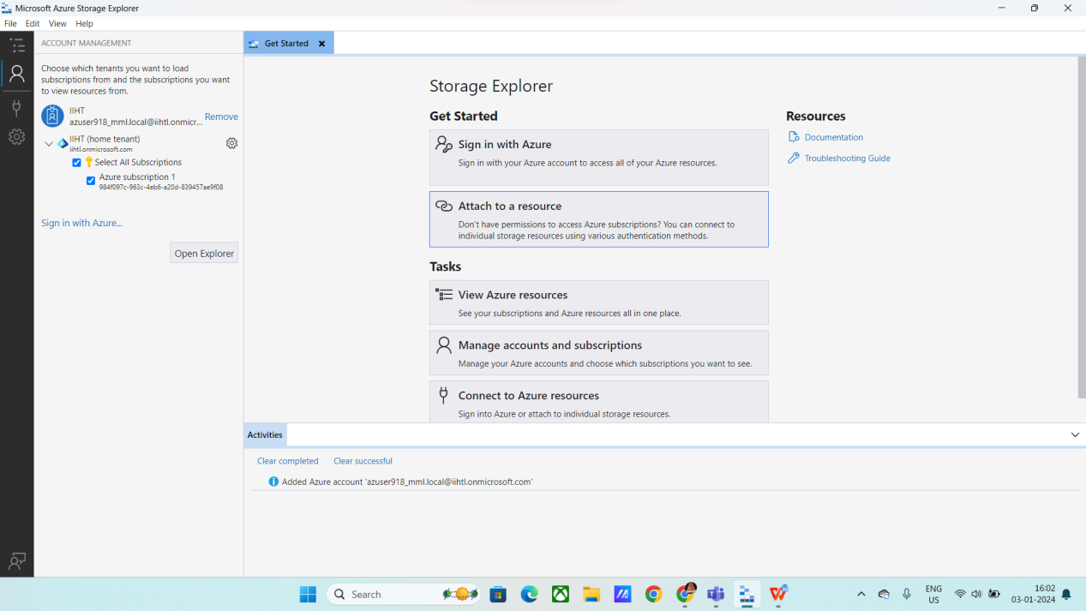

* First create storage account

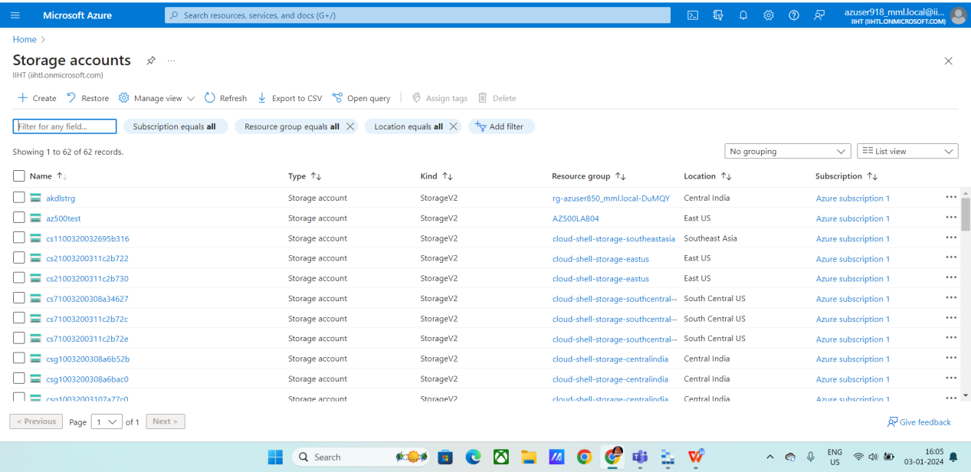

* Deployment is ready

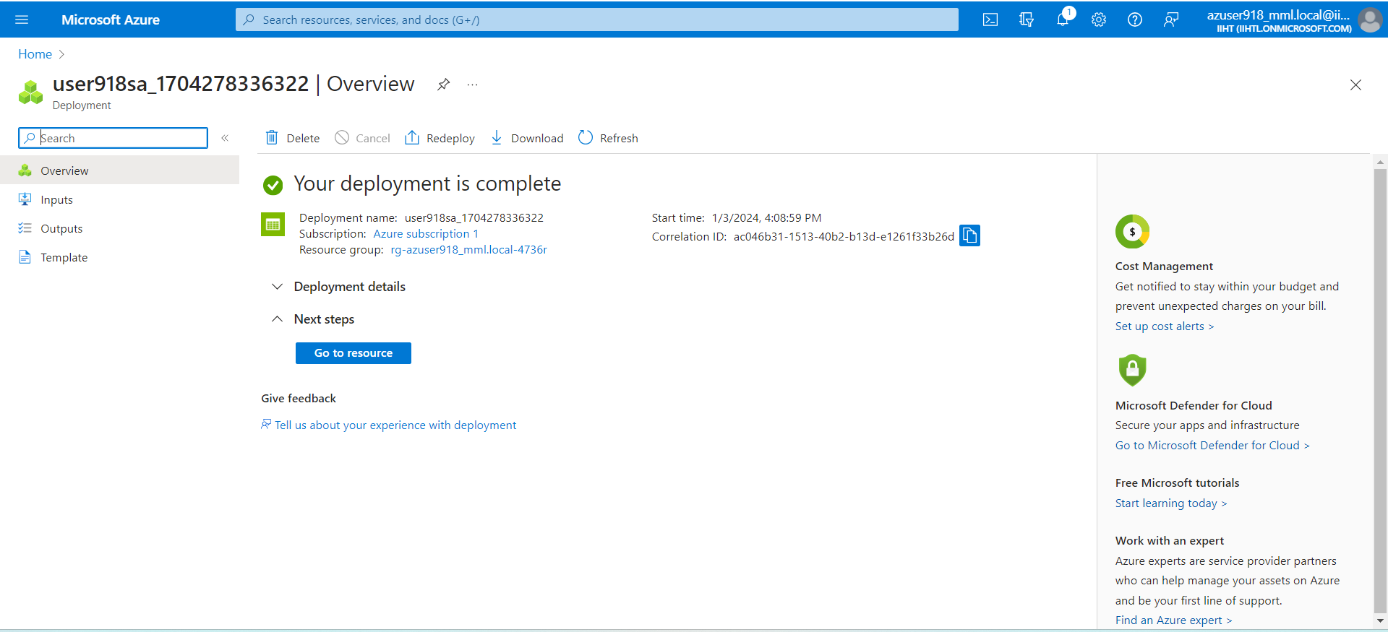

* Using string to connect storage explorer with gen 2

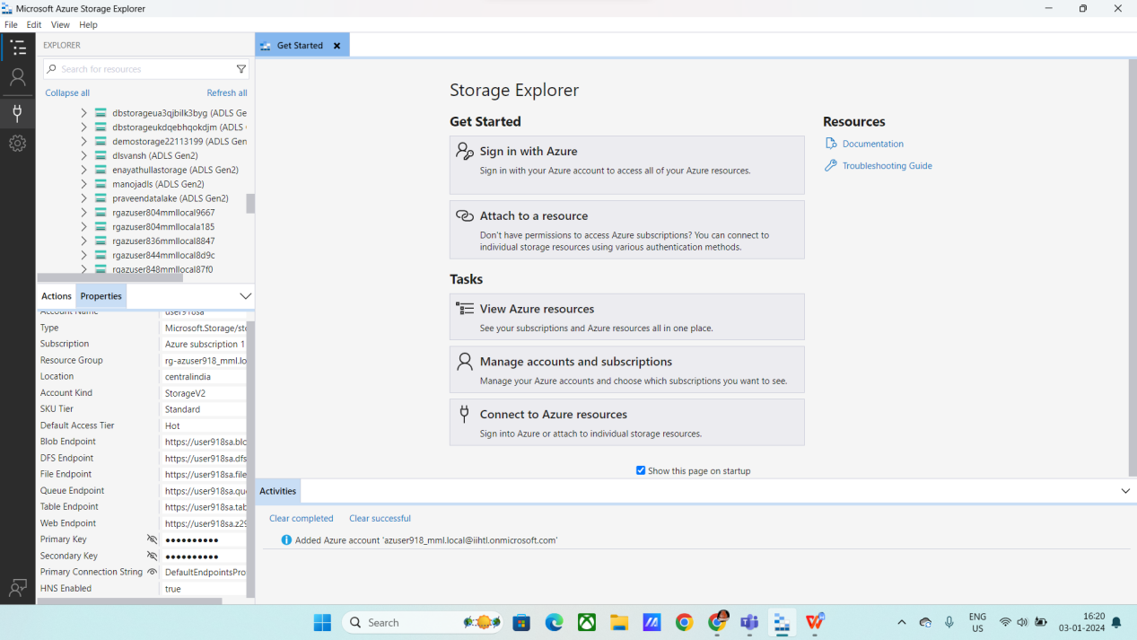

* Click on storage option and use string to connect.

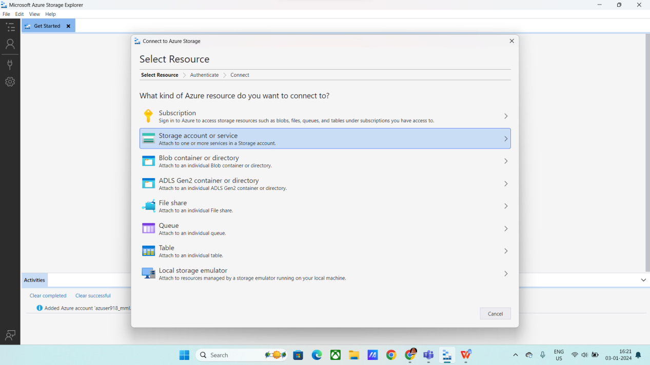

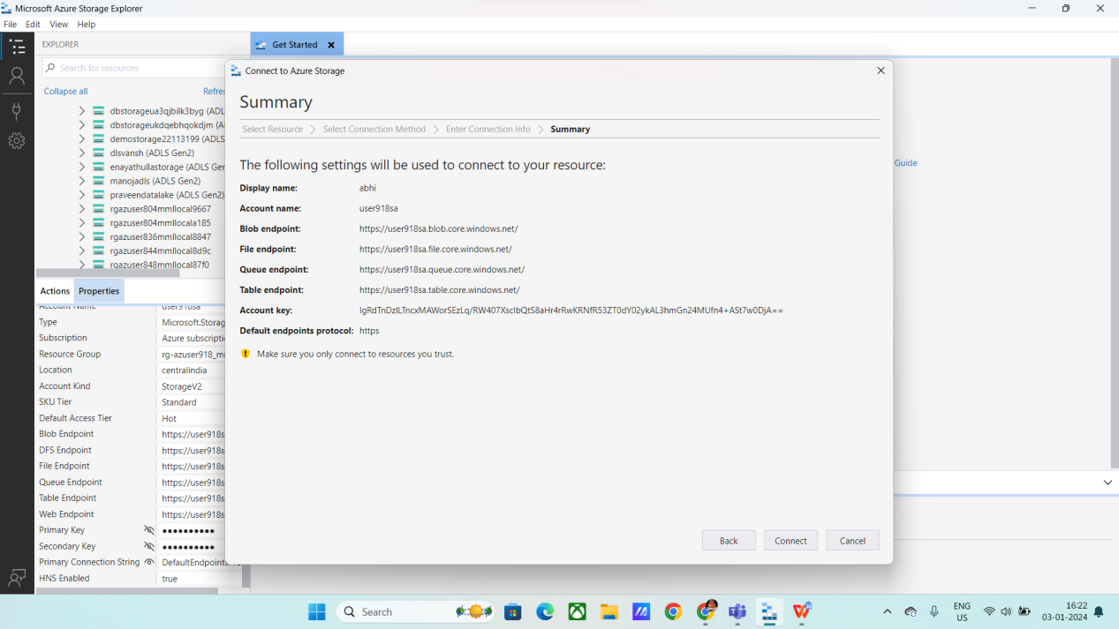

* Successfully connected

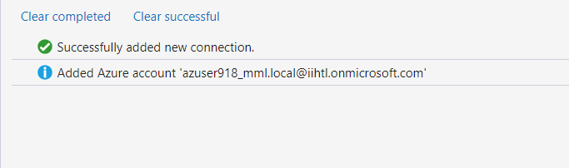

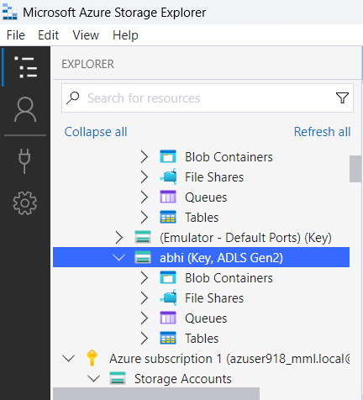

* Click on storage browser under storage container
* Click on blob container

**Blog storage**: Azure Blob Storage is Microsoft's object storage solution for the cloud. Blob Storage is optimized for storing massive amounts of unstructured data.

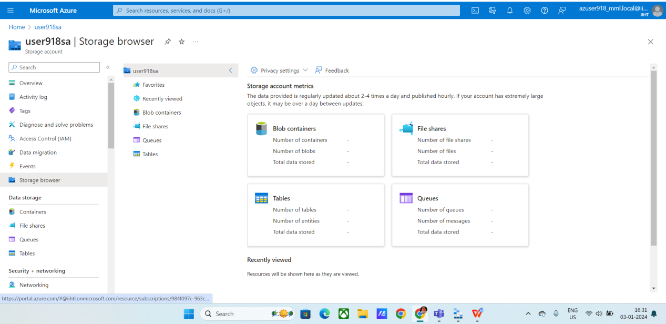

* Create a new blob container

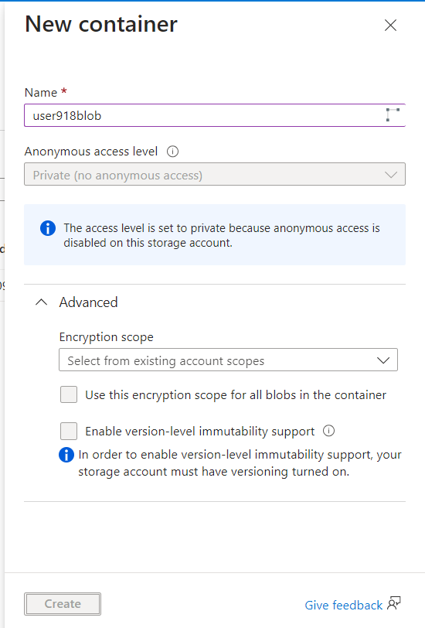

* After creating the blob container, click on upload data

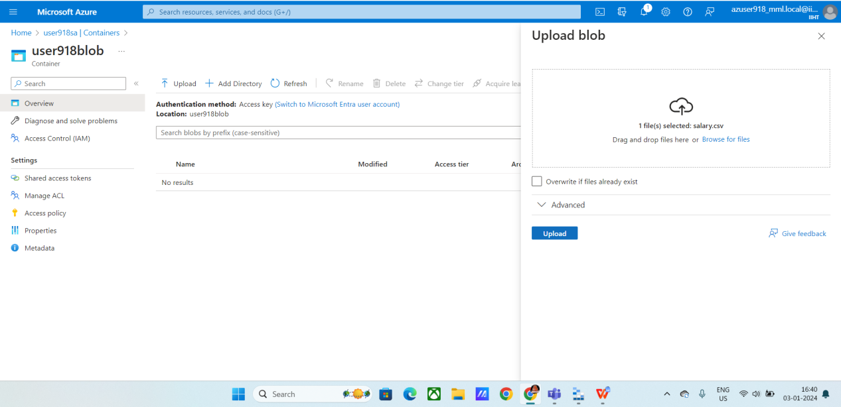

* Uploaded the csv file
* You can use text file or any kind of files.

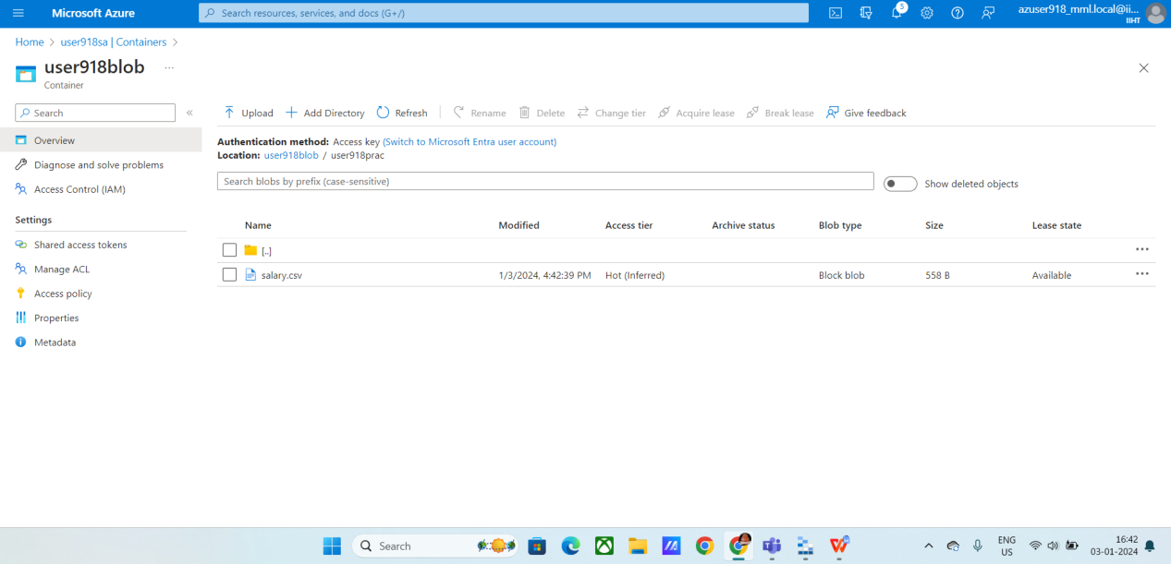

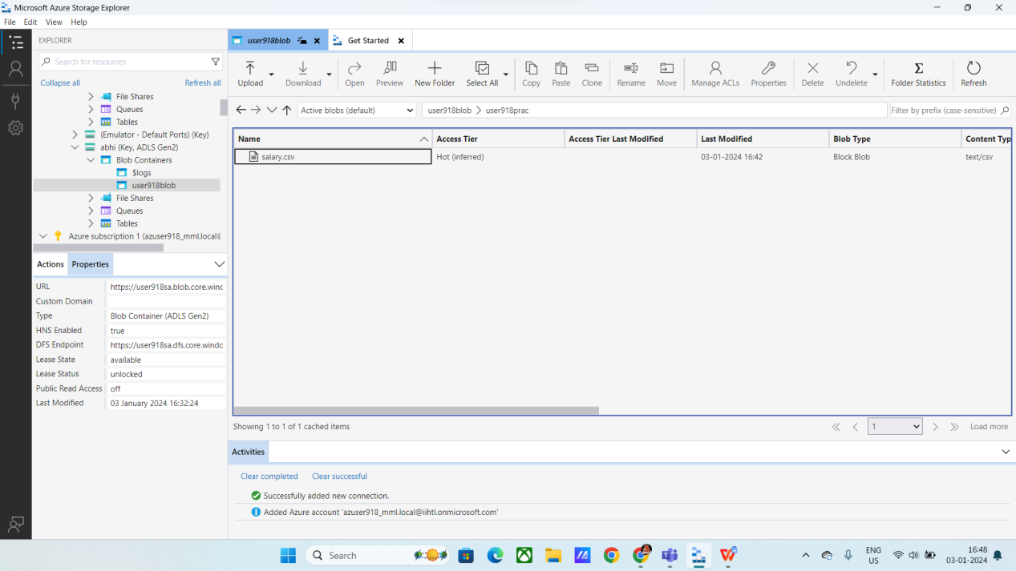

* Successfully connected the azure storage account with the storage explorer and uploaded the data.
* Now we can download the file.